Power BI Dashboard:
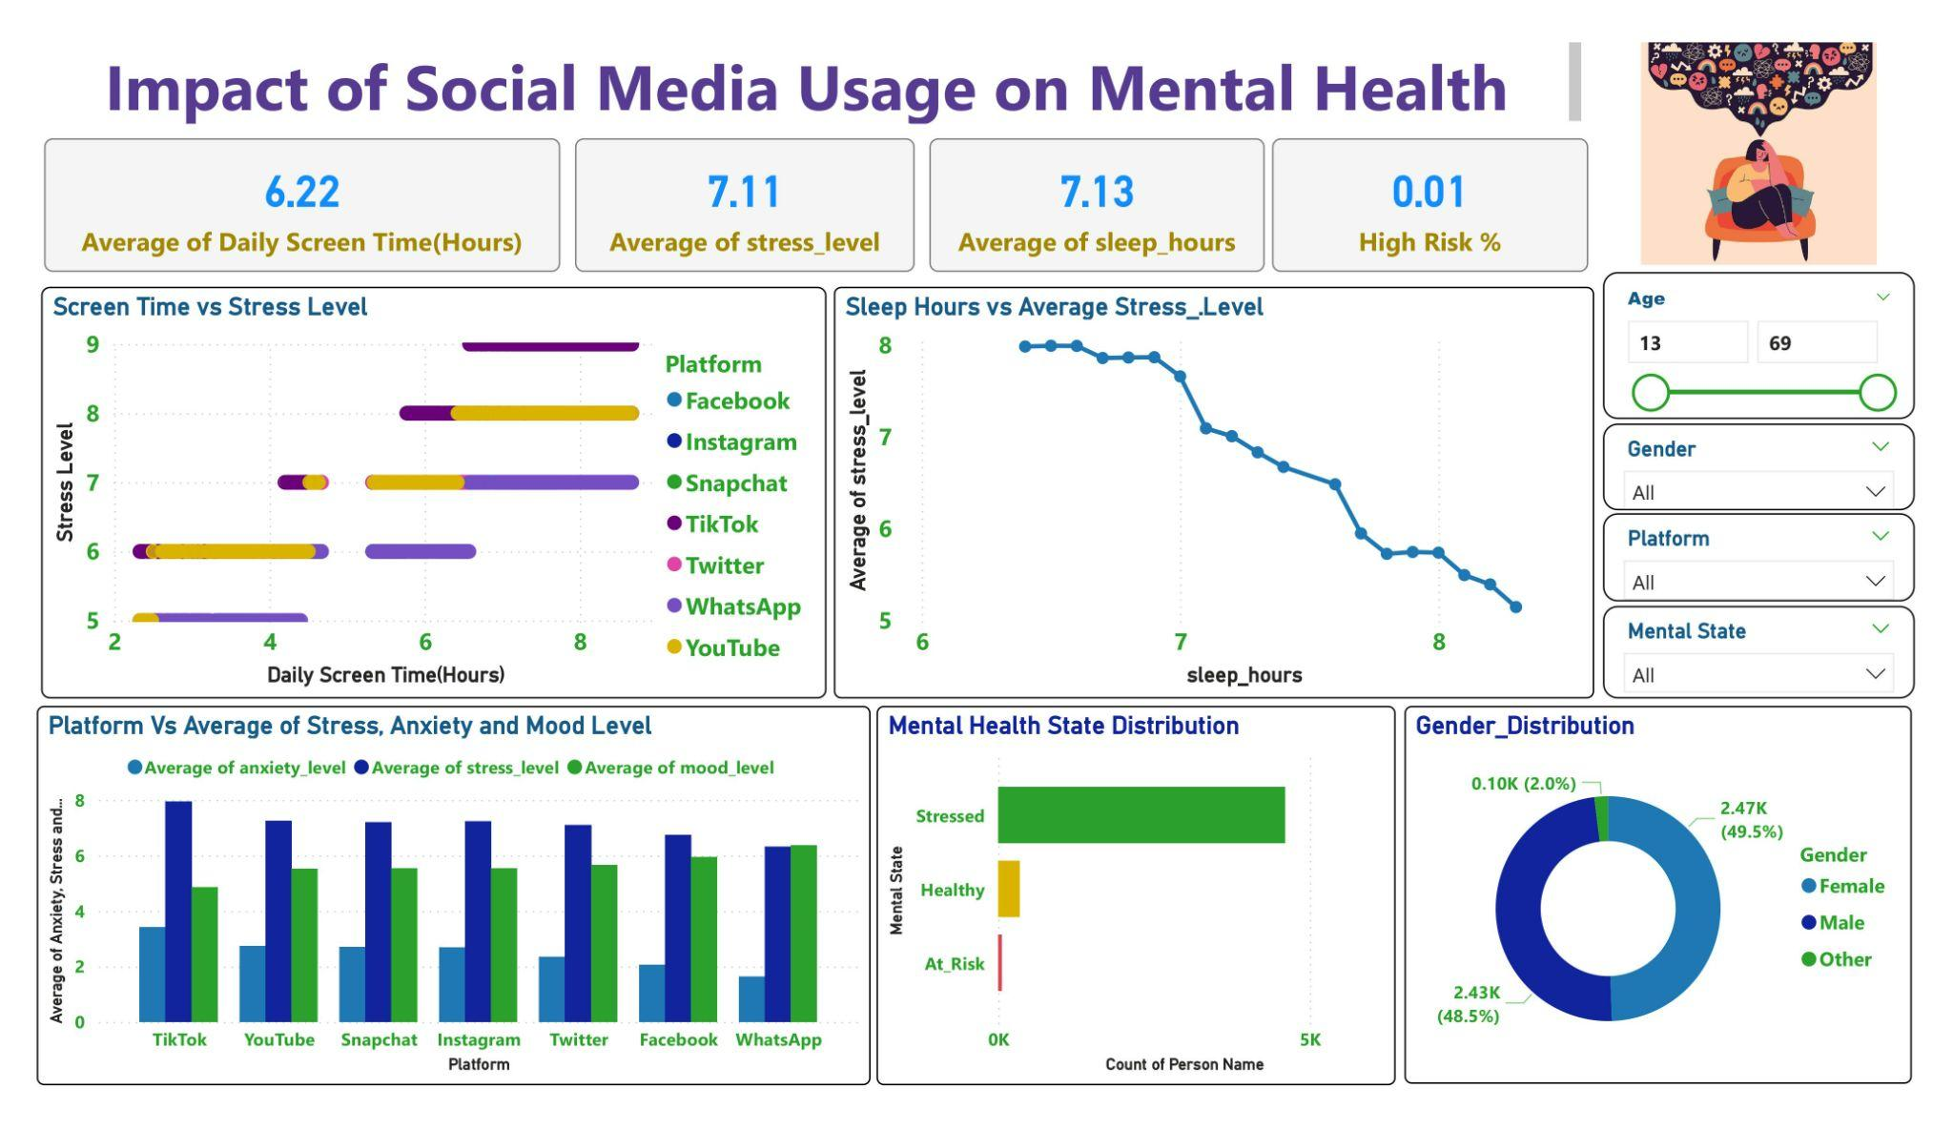Power BI Dashboard Overview
This Power BI dashboard analyzes the impact of social media usage on mental health by combining screen time, sleep patterns, platform usage, and mental health indicators such as stress, anxiety, and mood.

Dashboard Components
- KPI Cards: Average Screen Time, Stress Level, Sleep Hours, High-Risk %
- Screen Time vs Stress Level (Scatter Plot)
- Sleep Hours vs Average Stress Level(Line Chart)
- Average Mental Health Indicators by Platform (Bar Chart)
- Mental Health State Distribution (Bar Chart)
- Gender Distribution(Donut Chart)
- Interactive slicers (Age, Gender, Platform, Mental State) allow dynamic filtering.

Summary of Findings
The dashboard shows that people who spend more hours on social media tend to experience higher stress levels.Adequate sleep is strongly associated with lower stress, indicating sleep as a key protective factor.Certain platforms show higher average stress and anxiety, while others are linked to better mood levels.Most users fall into the “Stressed” category, while only a small portion are “At Risk” or “Healthy”.Mental health impact is consistent across genders, with no extreme imbalance.
Key Insights

1: Screen Time Increases Stress
- The Screen Time vs Stress Level chart shows a positive correlation.
- Users with 6–8+ hours of daily screen time report higher stress levels.
2: Sleep Reduces Stress Significantly
- The Sleep Hours vs Average Stress Level line chart shows a clear downward trend.
- Stress drops sharply when sleep exceeds 7 hours per day.
3: Platform Matters
- Platforms like TikTok and YouTube show higher average stress and anxiety.
- WhatsApp and Facebook show relatively lower stress and better mood levels.

4: Majority of Users Are Stressed
- The Mental Health State Distribution shows that most users fall under “Stressed”.
- Only a very small percentage are categorized as “At Risk”, but this group needs attention.
5: Gender Distribution Is Balanced
- The Gender Distribution donut chart shows nearly equal representation of male and female users.
- Mental health impact appears platform-driven rather than gender-driven.
Decision Making Recommendations

1: Promote Healthy Screen-Time Limits
- Encourage users to limit daily usage to under 5–6 hours.
- Introduce screen-time alerts or reminders.
2: Encourage Better Sleep Habits
- Platforms can introduce “sleep mode” notifications.
- Reduce late-night content push or autoplay features.

3: Platform-Specific Mental Health Interventions
- High-risk platforms should:
  - Promote positive content
  - Reduce exposure to toxic or addictive feeds
  - Introduce mental wellness breaks

4: Target Stressed Users
- Since most users are stressed:
  - Offer in-app wellness tips
  - Provide mental health resources and helplines
Final Dashboard Story
This dashboard shows that excessive social media usage increases stress, while adequate sleep helps reduce it. Certain platforms have a stronger negative impact on mental health, and most users are already experiencing stress. The analysis highlights the need for balanced social media use and mental health–focused platform design.

